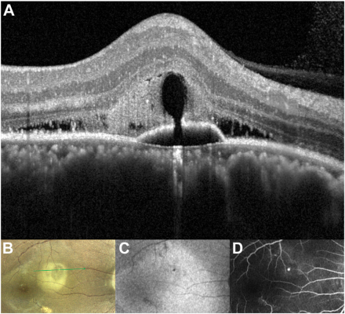

A 49-year-old man noted decreased visual acuity to 20/40 in the right eye because of central serous chorioretinopathy. His medicalhistory was unremarkable, and he took no medications. He worked nights for several years. High-axial resolution OCT (HighRes-OCTprototype) (A) revealed subretinal fluid and hyperreflective fibrin surrounding a hyporeflective lucency communicating with a pigmentepithelial detachment through a focal defect in an area of increased choroidal thickness. This defect corresponded to a hypopigmented spoton confocal color photography (B), which appeared hypoautofluorescent on fundus autofluorescence (C), and showed active hyperfluorescent leakage on fluorescein angiography (D).Based on the provided images and clinical description please make an ophthalmic diagnosis for this patient. And output the diagnostic conclusions only.

**Central Serous Chorioretinopathy**